
DATA SHEET
Date of update: 01.04.2026

MONBAT SLI PREMIUM EN NP90L5P0_1 100 Ah
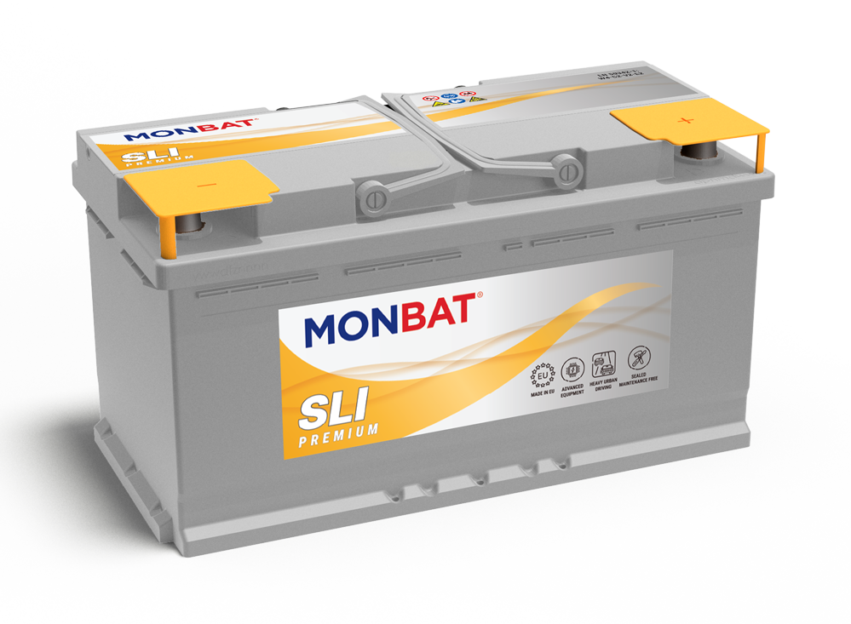

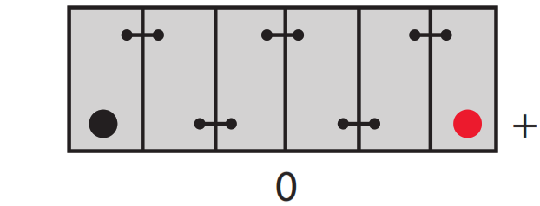
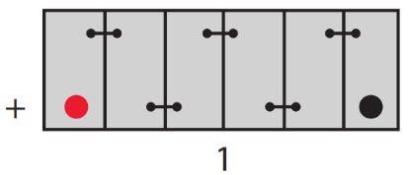
Mechanical specification
Dimensional group: | L5
ETN reference: | 600 044 092 SMF
DIN reference: | 60044
Dimensions^{A} in mm (LxWxH): | 353x175x190
Cell Layout: | 0
Terminal Type: | 1

According to EN 50342
Lid | Material | Polypropylene
Lid | Cover design | SMF
Lid | Colour | Grey

Hold-down

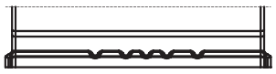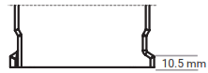

Layout

Separator
Type | PE

Weight^{B}
Battery weight in kg: | 17.10
Acid weight in kg: | 6.70
Total battery weight in kg: | 23.80

Battery classification as per EN 50342-1
Water consumption | Charge retention | Vibration resistance | Endurance Level
W4 | C2 | V2 | E2

Handles | Material | Polypropylene
Handles | Position | Top - on lid
Handles | Colour | Grey

Vent caps | Material | Polypropylene
Vent caps | Type | SMF
Vent caps | Colour | Grey

Container
Case | Material | Polypropylene
Case | Bottom hold-down | B13
Case | Colour | Grey

Electrical specification
Voltage: | 12V
Capacity C²⁰: | 100 Ah
Cold cranking current: | 900 A [EN]
Cold cranking current: | 920 A [SAE]

